Junior Infants Suggested Work 20/04/20 - 24/04/20
Suggested Priority Learning:
English | Phonics:  Revision of CK, R, E, M, H, D (see parent notes for suggested multi-sensory approach). Each day choose two sounds to play Treasure Hunt with.  How to Play Treasure Hunt:  Look at the letter and practice saying the sound and singing the song. Collect as many items you can find beginning with that sound in the house or draw as many things as you can see that begin with that sound. To increase the challenge set a timer!  Continued revision of all Jolly Phonics sounds and songs: https://www.youtube.com/watch?v=jvAYUvQUrGo  Reading:  Non-Fiction Reader 2 - The Farm (also available on Gill Explore under Unit 2). Read through half of the book with your child one day and play the oral language game below and half the next day. There are some additional activities inside the front and back cover of the book if you would like to use them too :)  Oral Language:  Target Vocabulary: farmer, scarecrow, hen, cow, calf, horse, foal, sheepdog, tractor, milking parlour, sowing seeds, ploughing, harvesting  Discuss the words as they come up in the reader and play ‘What Am I?’ - the adult describes an object or animal found on the farm and the child tries to guess what it is e.g It is a machine, with big wheels and the farmer drives it or it is where the cows go to get milked. The children can then take a turn describing after a few turns guessing.  Writing:  Five minutes per day practice handwriting patterns in Pattern Copy 1 (orange). Please encourage children to trace the pattern with their finger on the table, on their hand, in the air and in their copy before attempting with their crayon or pencil.
Maths | Topic 1 : Counting and recognition of number:  Ready Set Go Maths Counting Games: Pick and play games from the menu of suggested games.(See parent’s note on Teaching and Learning Guidelines sent via Aladdin on Monday 30th March for these games and for number formation songs.)  Online counting games:  https://www.topmarks.co.uk/learning-to-count/gingerbread-man-game  https://pbskids.org/curiousgeorge/busyday/hideseek/  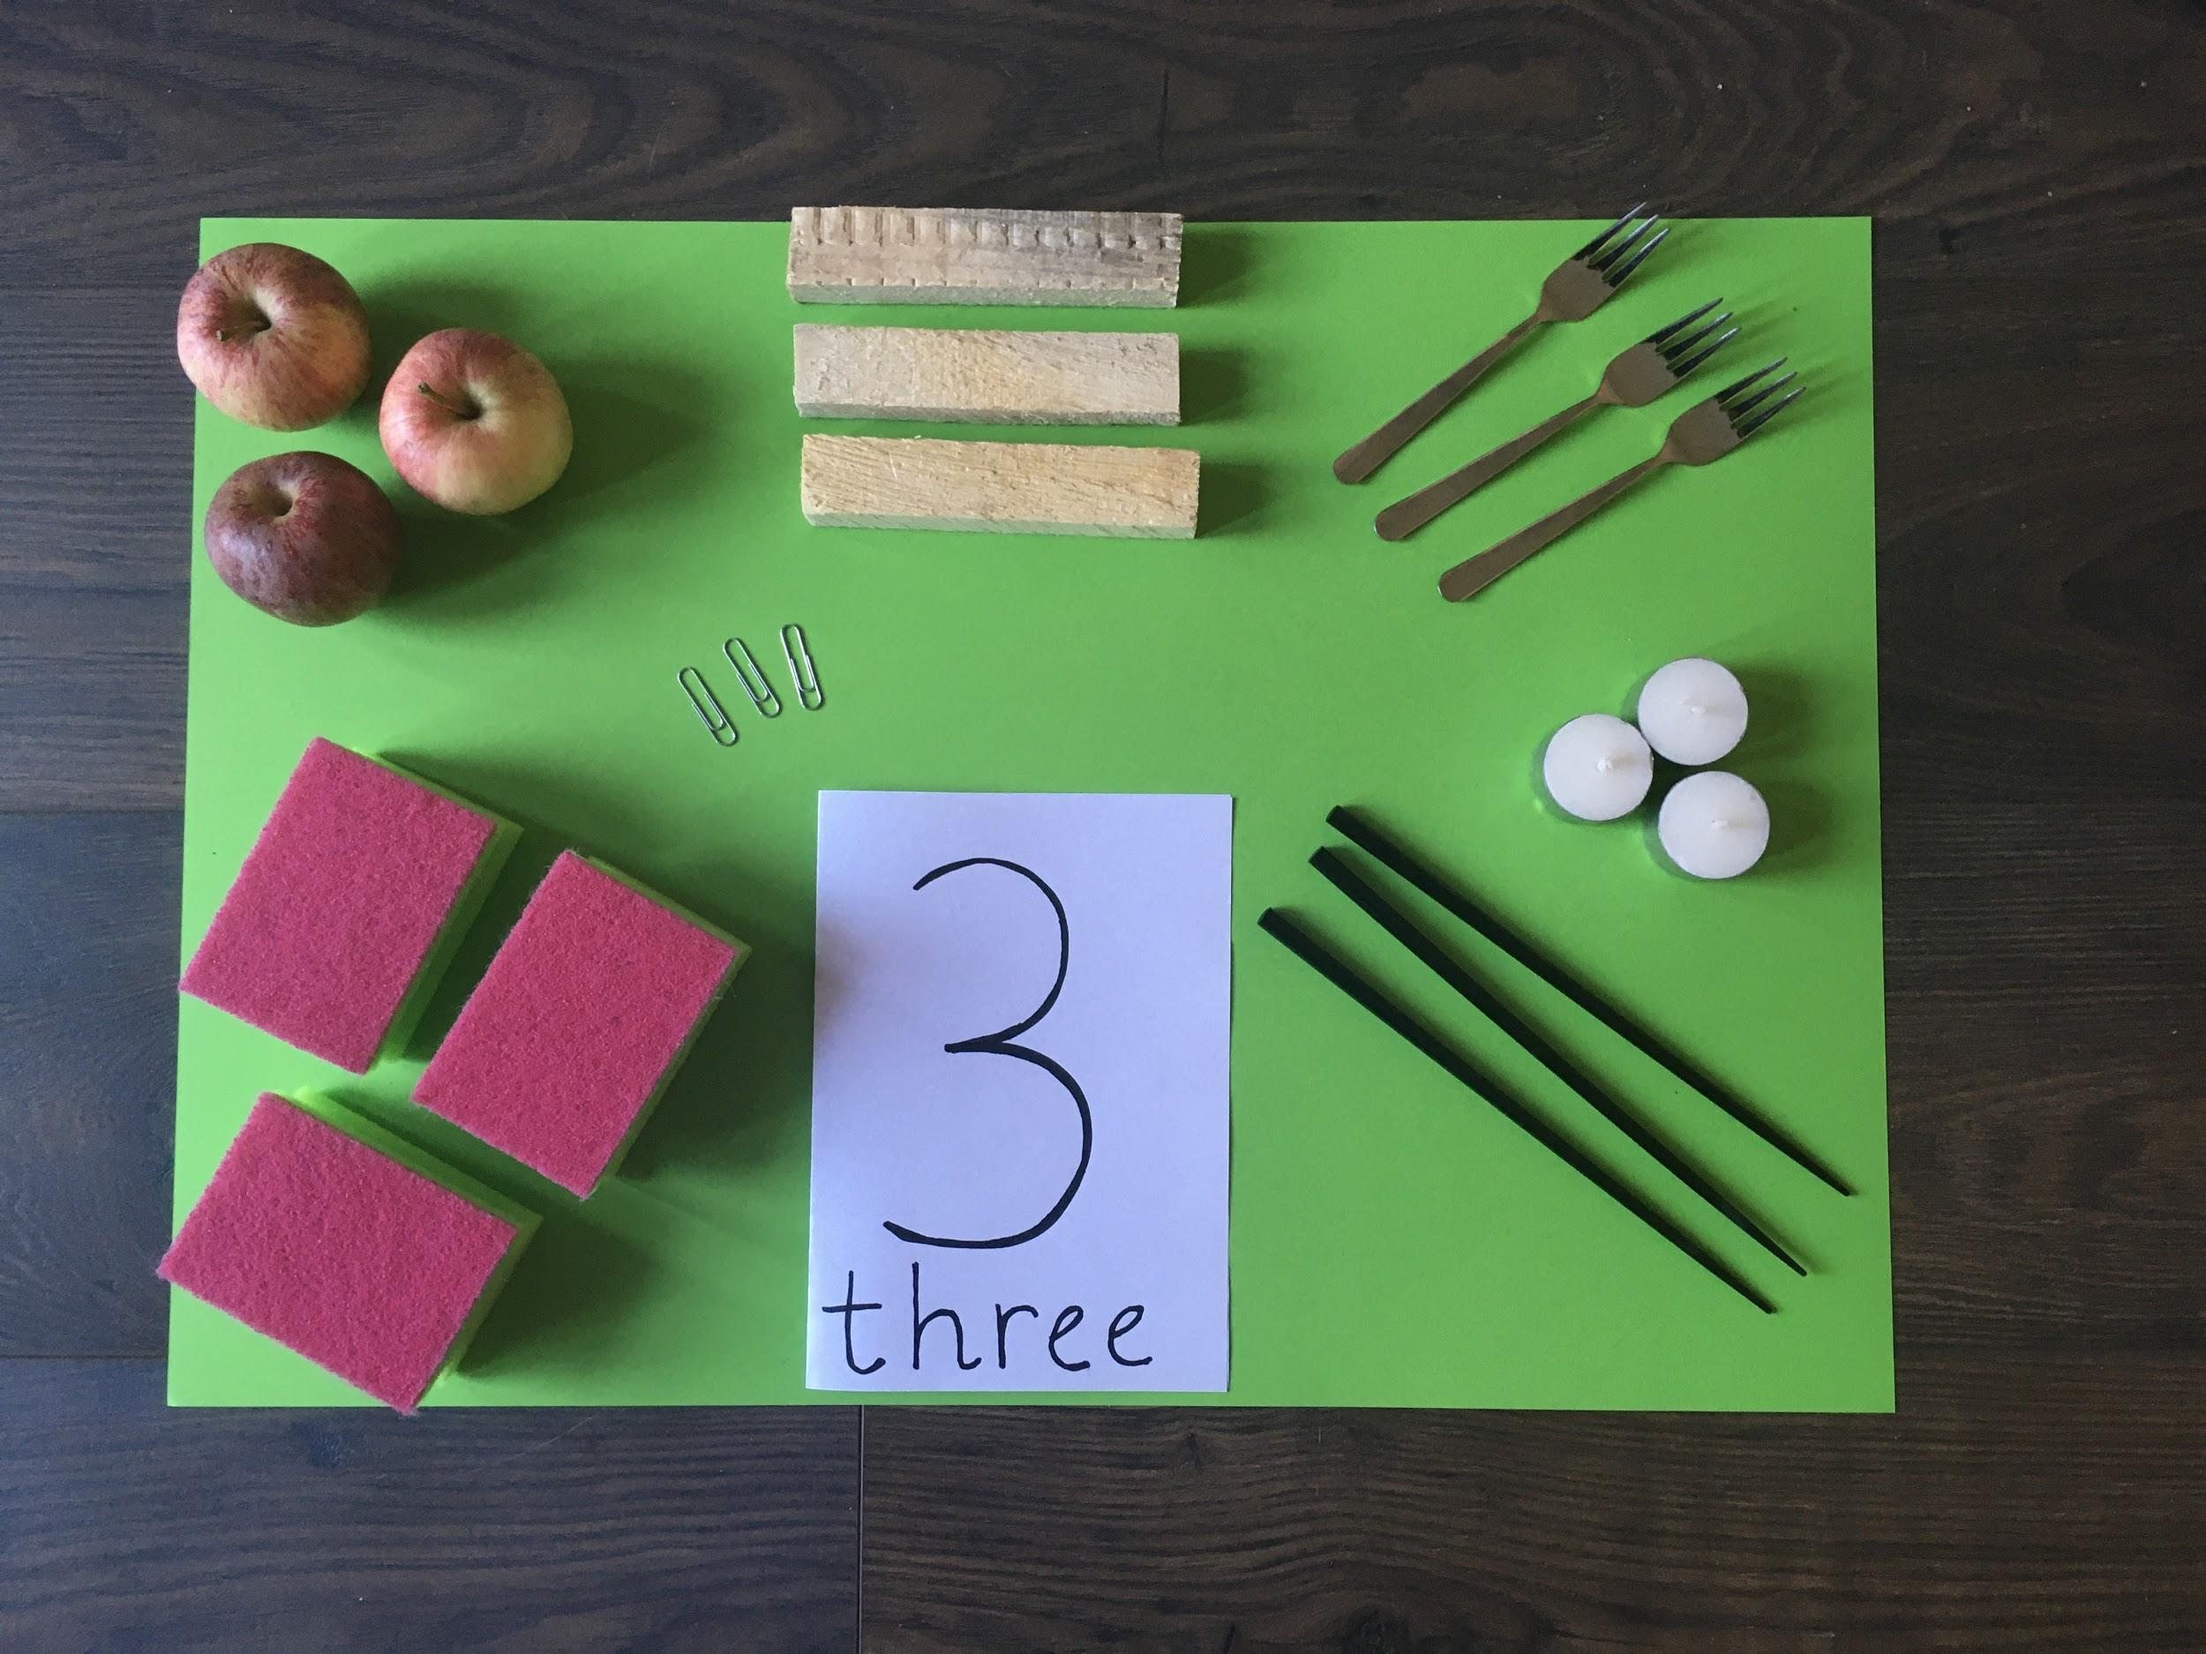  Making Sets: Please encourage your child to make a variety of different sets of three and four objects using items you have around your house.  Topic 2: Number 3:  https://www.twinkl.ie/resource/t-n-2546302-all-about-the-number-3-powerpoint  Complete powerpoint discussion and games for the number three.  Number formation:  Practice writing the number three.  Sing the ‘Number 3 Formation Song’ while writing.  Please encourage your child to write the number 3 with their finger on the table, on their hand, in the air, on your back and on a sheet of paper before attempting with their pencil.  Topic 3: Number 4:  https://www.twinkl.ie/resource/t-n-2546311-all-about-the-number-4-powerpoint  Complete powerpoint discussion and games for the number four.  Number formation:  Practice writing the number four.  Sing the ‘Number 4 Formation Song’ while writing.  Please encourage your child to write the number 4 with their finger on the table, on their hand, in the air, on your back and on a sheet of paper before attempting with their pencil.  Maths Copy:  Please ensure your child has completed pg.9-13 (number 3) and pg.18-22 (number 4) if they have not already done so.

Additional Optional Learning Activities:
Religion | Lesson: Places to Pray  Discuss the church and why it is a special and holy place where people go to pray and talk to God.  https://vimeo.com/161311356 - About the Church  Grow in Love page 42 and 43
Music | We are going to try learn a cheerful song this week to put a smile on everyone’s face:  https://www.youtube.com/watch?v=ru0K8uYEZWw  We can also practice our days of the week and months of the year songs:  https://www.youtube.com/watch?v=HtQcnZ2JWsY days of the week  https://www.youtube.com/watch?v=lPeAo1hz8GA months of the year
PE | We are learning the dance for the song “Can’t stop the feeling”.  Can you practice your singing and dancing?  https://www.youtube.com/watch?v=KhfkYzUwYFk  Guided P.E lesson by Joe Wicks (suitable for the whole family) https://www.youtube.com/watch?v=Rz0go1pTda8  Or any outdoor activity you would prefer :)
SESE | We will be linking our SESE learning to the farm this week.  VIsit the farm video:  https://www.youtube.com/watch?v=Hg2ZX0PF-jI  We are learning about the life cycle of a chicken. Follow the link to view a video  https://edcolearning.ie/Book/List  (go to Explore with me junior infants,  Click edco resources  Go to unit 7 spring  Choose the video - The life cycle of a chicken)  This is a sequencing activity that can be printed or done orally.  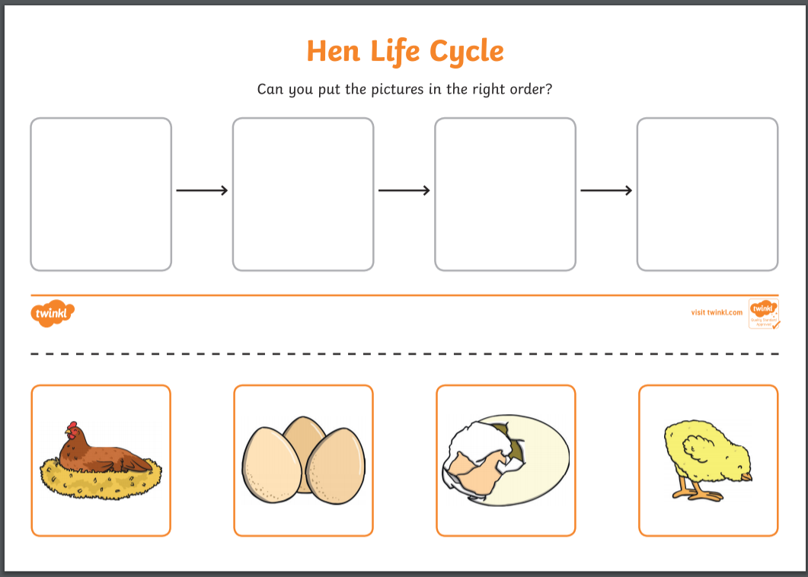
Gaeilge | We are going to practise some of our conversational Gaeilge:  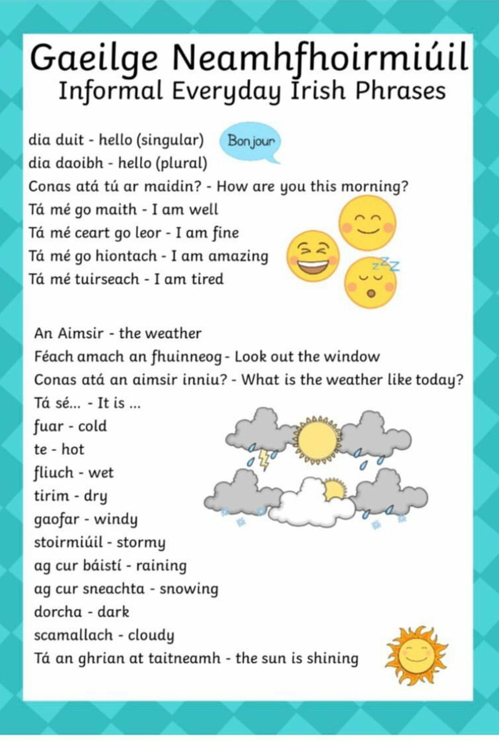  If you are unsure of pronunciation you can copy and paste these phrases into this website where it will read them aloud correctly:  https://www.abair.tcd.ie/en  The children might also like to sing the song ‘Tá an Lá Fliuch Inniu’ which we have done in class:  *to the tune of London Bridge*  Tá an lá fliuch inniu,  Fliuch inniu,  Fliuch inniu,  Tá an lá fliuch inniu,  Tá an lá fliuch.  Tá an lá tirim inniu,  Tirim inniu,  Tirim inniu,  Tá an lá tirim inniu,  Tá an lá tirim.

