Sightwords for Reader 8

Sightwords
came
over
ride
into
were
Tricky words
smelly
Thursday
Africa
Vocabulary words
animals
feathers
claws
world
favourite

The Zoo
At the zoo we saw a bear,
He had long, dark fuzzy hair.
We saw a lion in a cage,
He was in an awful rage.
We saw the big, long-necked giraffe,
And silly monkeys made us laugh.
But my favourite animal at the zoo
Is the elephant, how about you?
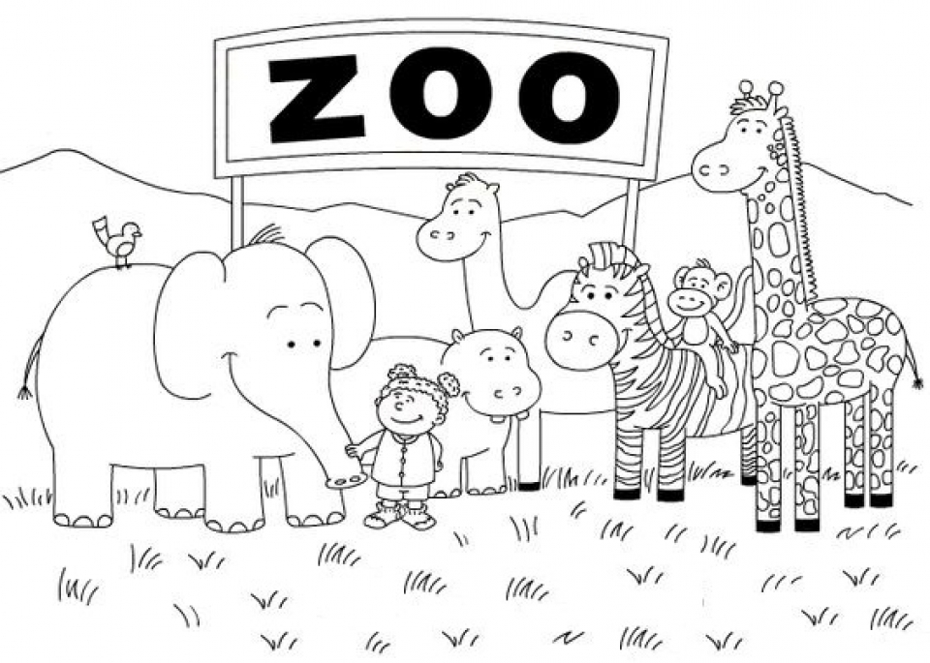

15-Minute Memory Activities

They say that the brain is like any other muscle in the body - the more you use it, the more developed it will become. Here are five quick and easy activities that will help you to develop your memory skills.
- The Suitcase Game
This is a round-the-table memory game. In a group, go around in turn and say what you are putting in the suitcase. Each person has to say all the other items as well as their own new one. If you get it wrong, you’re out! To keep things fresh, decide on a theme of the objects – it doesn’t always have to be travel-based.
- The Tray Game
Place 12 items on a tray and ask pupils to look at it for 20 seconds. Cover the tray with a cloth or other barrier and give pupils 30 seconds to write down everything they can remember. For a variation of this game, elect a pupil, or group of pupils, to look away (or leave the room). Remove one or several items from the tray and have them guess what has changed.
- Brain Yoga
Take your left hand, make a fist, and extend your thumb; holding this, do the same with your right, only extend your little pinky. Now change them so it’s left pinky and right thumb. The co-ordination involved will strengthen neural connections, which will help develop the memory!
- The Concentration Game
Get a deck of card and lay out all 52 cards in four rows of 13 (you can include the jokers in six rows of nine cards each, if you prefer). Players take turns choosing two cards, placing them face up. If they are of the same suit and colour (for example, six of diamonds and six of hearts) that player wins the pair and plays again. If the cards are not of the same suit and colour, the player has to return the cards to the board face down and play passes to the player on the left. The game ends when a player picks the last pair. The winner is the person with the most pairs. Players may end up in a tie for first place, depending on the size of the group.
- Matching Pairs
This is another game that can be played with a deck of cards. Cards are laid face down on a surface and two cards are flipped face up for each turn. The object of the game is to turn over pairs of matching cards (you can choose how a ‘match’ is made, whether it be cards of the same suit, or the same number – maybe even incorporate two decks and play for exact matches). If a player succeeds in matching a pair, they have another turn and continue until they fail to match two cards. Flip the cards back over after a turn has ended. The object of the game is to find the most matches in a row – with the ultimate being matching the whole deck – so players must watch carefully as others take a turn.

