*The* ***‘Blue Shield Flag Team’*** *in school have organised a* ***‘Friendship and Wellness Week’*** *that the boys and girls can do at home this year. Our slogan in school is* ***‘Smiles are our Superpowers’.***

*We will celebrate it on Monday 25th – Friday 29th of May. We hope that you enjoy the suggested ideas😊.*



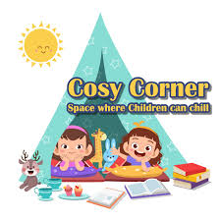

***Links***

*Listen to Friendship story: Theo’s New Friend* [*https://www.youtube.com/watch?v=5rU6fOJMjA8&ab_channel=NewAppsforKidsonIpadiPhoneAndroidComputer*](https://www.youtube.com/watch?v=5rU6fOJMjA8&ab_channel=NewAppsforKidsonIpadiPhoneAndroidComputer)

*Relaxation techniques podcast from NEPS for parents and children:* [*https://soundcloud.com/user-719669409/relaxation-techniques-30-03-2020*](https://soundcloud.com/user-719669409/relaxation-techniques-30-03-2020)

*PDST relaxation tools for children:* <https://www.pdst.ie/primary/healthwellbeing/relaxationandself-regulationtools>

*Suggestions for the day:*

* *Create a Friendship poster with the slogan* ***‘Smiles are our Superpowers’***
* *Sit outside for 5 minutes and listen for the furthest sound you can hear*
* *App:* ***Mindful Gnats.*** *For mindfulness and relaxation*
* *Have a picnic/lunch outside*
* *Make a cosy corner/area in your home*
* *Play some of your favourite music*
* *Go on a nature walk – what do you see or hear?*
* *Try a new recipe, baking at home*
* *Compliment circle (sit in a circle and give each member of your family a compliment!)*
* *Complete a Random Act of Kindness for someone in your family 😊*

