Junior Infants Suggested Work 05/05/20 - 08/05/20
Suggested Priority Learning:
English | Phonics:  Revision of AI, J, OA, IE, EE/OR (see parent notes for suggested multi-sensory approach). These sounds can be tricky for the children, it may help to listen to the story and songs for each sound on the Jolly Phonics app. Play oral language riddles with the sounds and encourage the children to come up with some more rhyming words.  Some examples of riddles:  - I am thinking of a word that rhymes with rain, when something hurts it's called a…(pain)  - I am thinking of a word that rhymes with goat, you wear it outside it’s a…(coat)  - I am thinking of a word that rhymes with coat, it sails on the sea it’s a… (boat)  - I am thinking of a word that rhymes with oat, it’s an animal on the farm its a… (goat)  - I am thinking of a word that rhymes with free, it's a black and yellow insect its a…(bee)  - I am thinking of a word that rhymes with pie, it's something you wear around your neck its a…(tie)  Reading:  Fiction Reader 4 - Toys (also available on Gill Explore under Unit 4). Read through the book with your child and talk about toys that you played with when you were a child. There are some additional activities inside the front and back cover of the book if you would like to use them too :)  Writing:  Five minutes per day practice handwriting patterns in Pattern Copy 1 (orange). Please encourage children to trace the pattern with their finger on the table, on their hand, in the air and in their copy before attempting with their crayon or pencil.
Maths | Topic 1 : Counting and Recognition of Number:  Ready Set Go Maths Counting Games: Pick and play games from the menu of suggested games.(See parent’s note on Teaching and Learning Guidelines for these games and number formation songs.)  Online counting games:  Number Games for Kindergarten Kids Online - SplashLearn  Open the above link, select and play the ‘Count with Counters’ game. Then scroll down, select and play the ‘Count in Different Arrangements’ game.  Counting Game: Roll and Make Sets: Get your child to roll a dice. Then your child needs to identify the number they have rolled and make a set of objects that corresponds to this number. Please encourage your child to make these sets using items you have around your home.  If you do not have a dice please use the link below to roll an online dice.  https://www.online-stopwatch.com/chance-games/roll-a-dice/full-screen/  Topic 2: Number 5:  Number formation:  Practice writing the number three.  Sing the ‘Number 5 Formation Song’ while writing.  Please encourage your child to write the number 5 with their finger on the table, on their hand, in the air, on your back and on a sheet of paper before attempting with their pencil.  Topic 3: 2D Shapes (Triangle,Circle, Square, Rectangle)  Revise this topic with your child by completing art activity ‘Shapes Robot’. (see Art below)  Listen to the song: ‘The 2D Shapes that I know.’  2D Shapes I Know song for kidswww savevid com  After listening to the song, see if your child can use their ‘Maths Eyes’ to spot 2D shapes around your home.  Online 2D shapes game:  https://www.topmarks.co.uk/early-years/shape-monsters  Maths Copy:  Please ensure your child has completed pg.26-27 (Drawing sets of 2-5) if they have not already done so.

Additional Optional Learning Activities:
Religion | Grow in Love: Seasonal Lessons  Lesson 5: Mary  Discuss May as a special month when we remember Mary  Grow in Love page 62 and 63  Parents can now login to the Grow In Love website  https://app.growinlove.ie/en/login  Email: trial@growinlove.ie  Password: growinlove
Art | Using the 2D shapes we have learned about (square, rectangle, circle, triangle) design and draw a robot.Here is an example of how it might look:  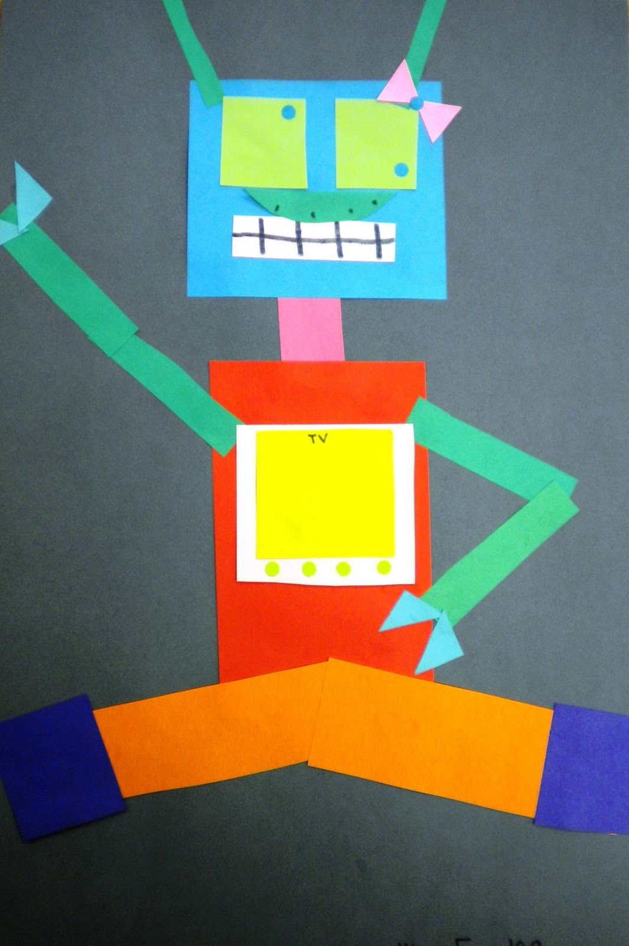  Alternatively this is a pre-made robot that you can print and colour:  http://www.benscoloringpages.com/coloringpages/shapesrobot.php
PE | This week we are moving onto the strand of gymnastics. Attached is a video lesson plan from DCU on gymnastics suitable for home using little to no equipment.  Junior Senior Lesson 1 (Gymnastics): https://business.facebook.com/155235547878911/videos/830901450738805/  Or any outdoor activity you would prefer :)
SPHE | We are aware that every child is experiencing and exploring our new normal reality in their own way. Some children may be coping excellently and love the time at home, while others may find the change in routine difficult and may behave in ways that are not typical to their personality.  In order to support you in this transition we are including some resources which give stories and activities that can help.  The Little Elf who missed his Birthday Party Story  https://drive.google.com/file/d/17cBr1p_PfwXWOODNvl3CaWfb1qw8vzwP/view?usp=sharing  A therapeutic story to support primary-age children in exploring strong emotions linked to the coronavirus pandemic.  Calm Club: Daily calming activities for children:  https://drive.google.com/file/d/1peLN96F-XvQGUKWhmuH5qnht4DfbIu6q/view?usp=sharing  Calm down brain break breathing activities:  https://drive.google.com/file/d/1Ii8NFqF9m90Wn0IREt_38rVvwIe8Tyw6/view?usp=sharing  These sequences of activities can be used to calm and relax children before work or play. At this time children may need an adult to teach and model these calm exercises. These activities are useful to teach children how to self-regulate.
Gaeilge | The children might also like to say or sing the following song that they already learned:  Rolaí, Polaí  Rolaí, Polaí, Rolaí, Polaí,  Suas,Suas,Suas.  Rolaí, Polaí, Rolaí, Polaí,  Síos,Síos,Síos.  Rolaí, Polaí, Rolaí, Polaí,  Amach, Amach, Amach.  Rolaí, Polaí, Rolaí, Polaí,  Isteach, Isteach, Isteach.  Rolaí Polaí by Junior Infants  English Translation  Roley, Poley,  Roley, Poley,  Up, Up,Up.  Roley, Poley,  Down, Down, Down.  Roley, Poley,  Out, Out, Out.  Roley, Poley,  In, In, In.  If you are unsure of pronunciation you can copy and paste these phrases into this website where it will read them aloud correctly:  https://www.abair.tcd.ie/en
Additional English Readers | For anyone who would like access to additional reading material, we would recommend the following websites:  https://www.oxfordowl.co.uk/for-home/find-a-book/library-page/  - Children have access to an online library of readers here and a variety of activities to browse through. You can set up your own account to access these readers and activities for free.  https://www.starfall.com/h/ltr-classic/?mg=m  - There are lots of fun, engaging reading activities and games on this website

