Day | Target language | Questions
Monday  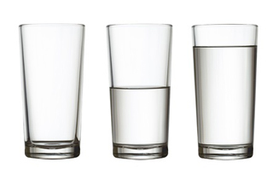 | Full/empty | - Can you find containers or food items that are full?  - Can you find empty containers (maybe in the clean recycling bin?)  - What is the difference between full and empty?
Tuesday  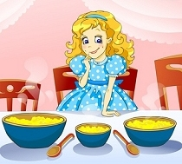 | Small/medium/large | - Can you find a big bowl/cup for daddy bear, a medium bowl/cup for mammy bear and a small bowl/cup for baby bear? Can you test them with water..which holds most/least? How do you know?  - How many times do you have to fill baby bears bowl/cup to fill mammy’s/daddy’s bowl? Have an estimate before you try it out…were you close?
Wednesday  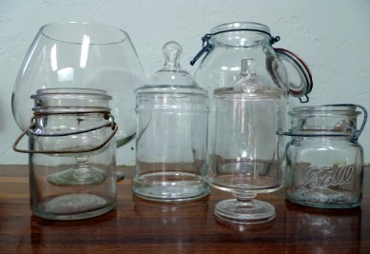  This Photo by Unknown Author is licensed under CC BY-ND | More/ less | - Find various containers of varying sizes e.g. an egg cup, a yogurt cup, a cup, a bowl, a jug…  - I spy with my little eye something that will hold more than an egg cup…less than a cup etc
Thursday  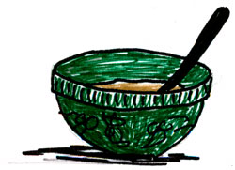 | Informal measures | - Pick a small container to measure with e.g. egg cup and estimate how many it will take to fill a larger container e.g. the cup. Then see how close you were (Remember an estimate does not have to be correct!!)  - Repeat using a glass/jug to fill larger containers.

