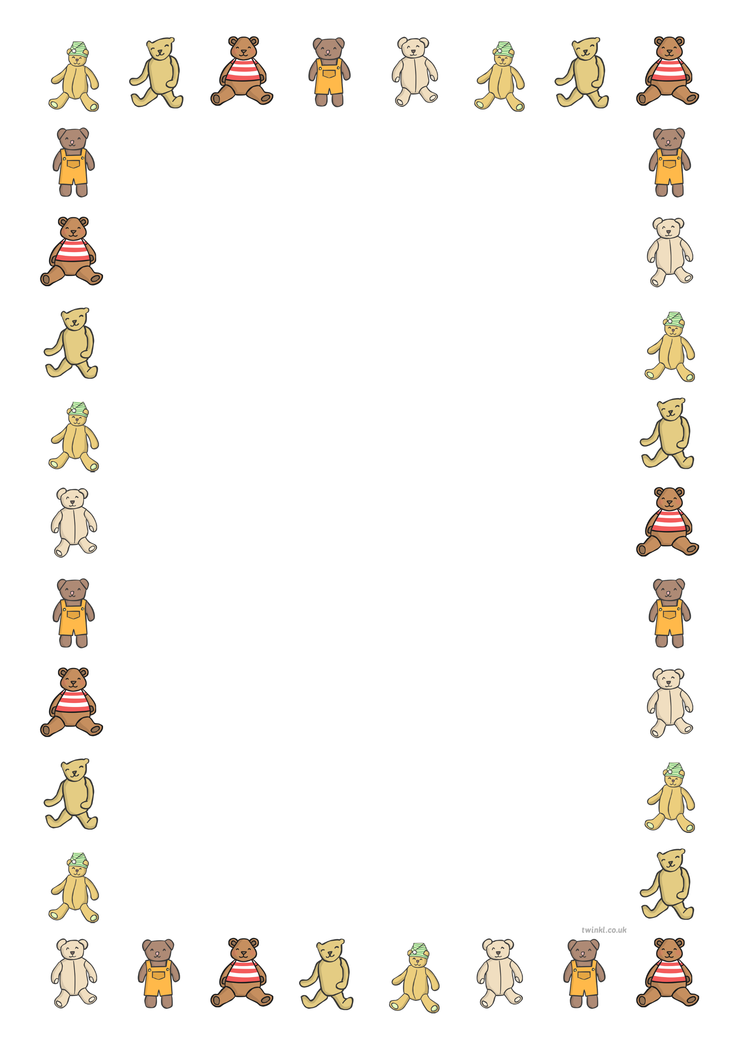
Senior Infants Weekly Plan: Week beginning 22nd June 2020
Dear Parents,
We hope you are all keeping well. As this is our last formal week of planning, we are sending you a plan based around having a Teddy Bear’s Picnic. Activities within the plan will reflect this theme.
Our plans are also available on the school website www.sfxns.ie. As always, we are contactable on our emails. Have a lovely weekend.
Ms Barrett, Ms Cummins, Ms Murray, Mrs Mulready.
There’s lots to prepare for a Teddy Bears’ Picnic.
- Read/watch the story “The Teddy Bears’ Picnic. https://www.youtube.com/watch?v=uxFIGWm9M6w
- Colour by number – Teddy Bear’s Picnic (attached pdf)
- Let’s make an invitation. Who are you going to invite? You can write it in your copy or design one on card/paper.
- What food are we going to have? Create a menu – The food can be real or make believe. (attached pdf for menu and Powerpoint on ‘How to make a Smoothie)
- What music and games will you play at your picnic? (Kim’s game with your picnic food, Hide and Seek with Teddy, See lyrics below)
- Design some placemats and decorations.
- Gaeilge – Amhrán (song): Tá téidí sa seomra suí - https://www.youtube.com/watch?v=HvqxVjU9eRc
Here are some ideas.
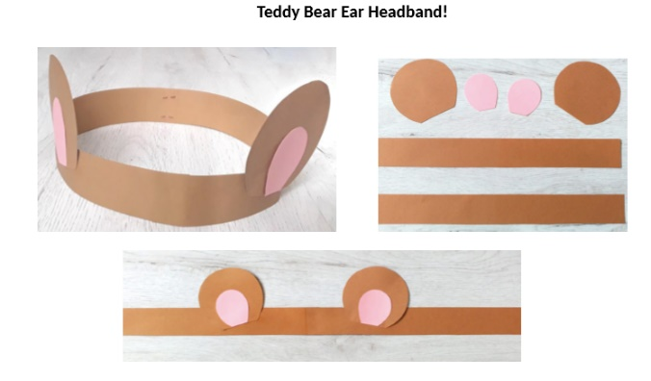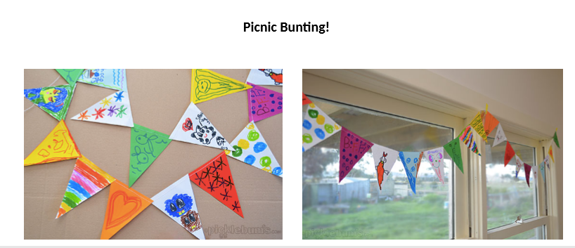
- We’re ready to have our picnic! Set it up and bring all your teddies/toys. It can be indoors or outdoors. Enjoy and take lots of pictures!
Teddy Bears Picnic

If you go down in the woods today
You're sure of a big surprise
If you go down in the woods today
You'd better go in disguise!

For every bear that ever there was
Will gather there for certain
Because today's the day the
Teddy Bears have their picnic

