[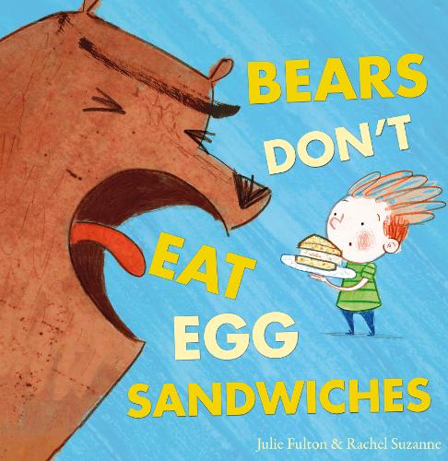](https://www.amazon.co.uk/Bears-Dont-Eat-Egg-Sandwiches/dp/1848862830?tag=schoolreadinglist-21)[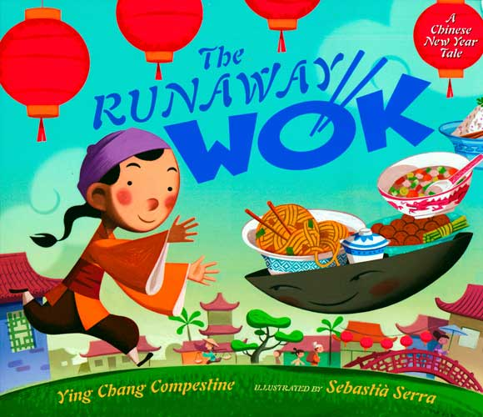](https://www.amazon.co.uk/Runaway-Wok-Chinese-Year-Tale/dp/0525420681?tag=schoolreadinglist-21)

[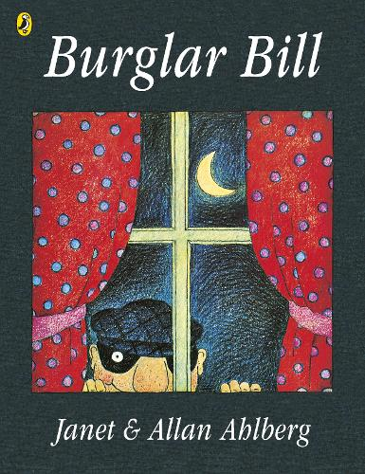](https://www.amazon.co.uk/Burglar-Picture-Puffin-Allan-Ahlberg/dp/0140503013?tag=schoolreadinglist-21)[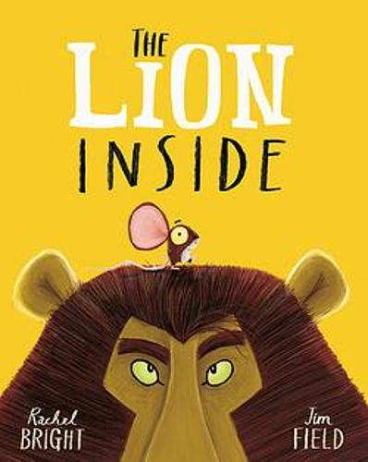](https://www.amazon.co.uk/Lion-Inside-Rachel-Bright/dp/1408331608?tag=schoolreadinglist-21)

[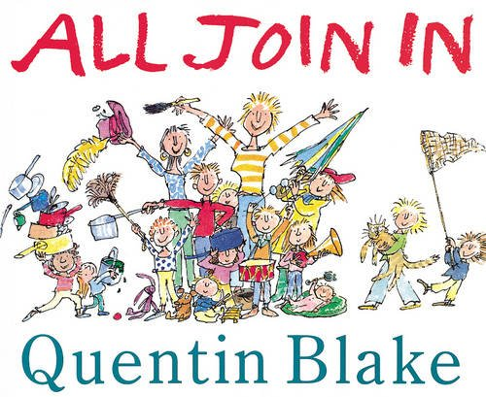](https://www.amazon.co.uk/All-Join-Red-Picture-Books/dp/0099964708?tag=schoolreadinglist-21)

[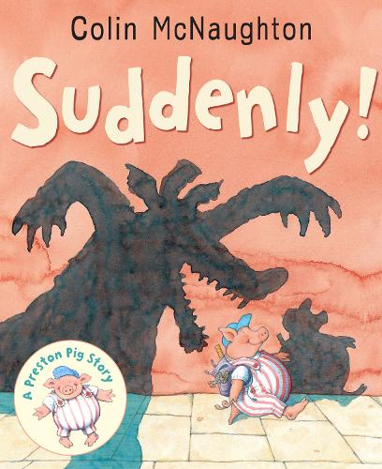](https://www.amazon.co.uk/Suddenly-Preston-Story-Colin-McNaughton/dp/1842706217?tag=schoolreadinglist-21)[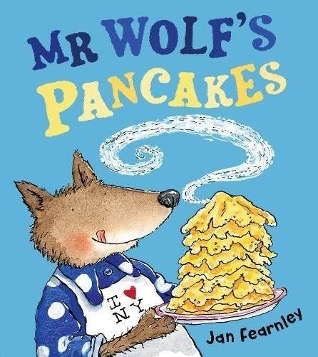](https://www.amazon.co.uk/Mr-Wolfs-Pancakes-Jan-Fearnley/dp/1405288582?tag=schoolreadinglist-21)

[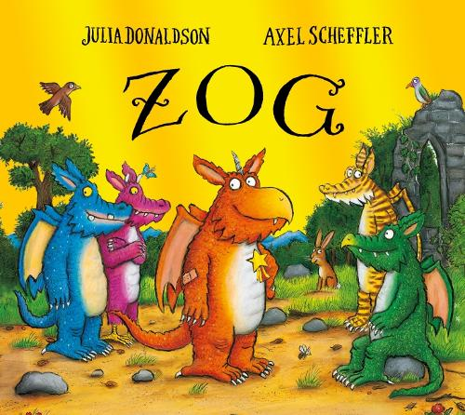](https://www.amazon.co.uk/Zog-Julia-Donaldson/dp/1407186957?tag=schoolreadinglist-21)[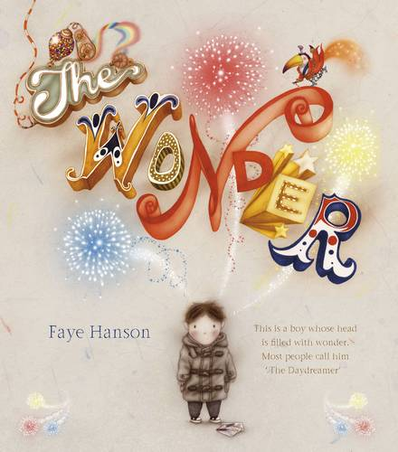](https://www.amazon.co.uk/Wonder-Faye-Hanson/dp/1783701145?tag=schoolreadinglist-21)[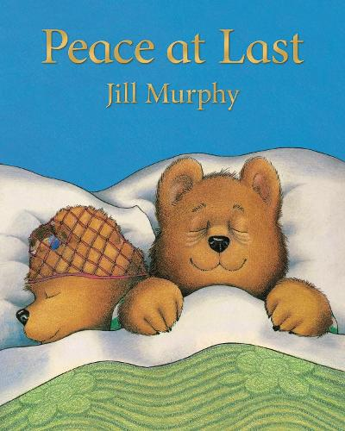](https://www.amazon.co.uk/Peace-at-Last-Jill-Murphy/dp/1509862595?tag=schoolreadinglist-21)

[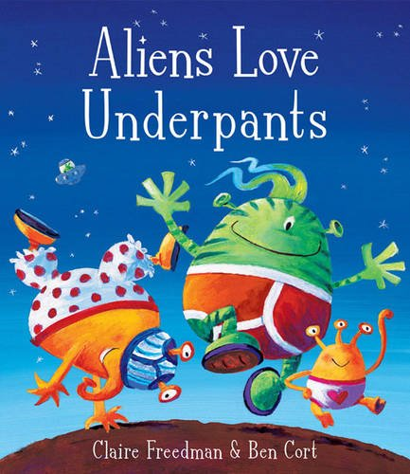](https://www.amazon.co.uk/Aliens-Love-Underpants-Claire-Freedman/dp/1416917055?tag=schoolreadinglist-21)[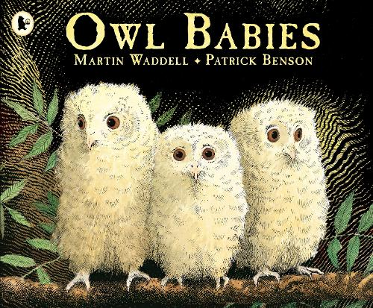](https://www.amazon.co.uk/Owl-Babies-Martin-Waddell/dp/0744531675?tag=schoolreadinglist-21)

[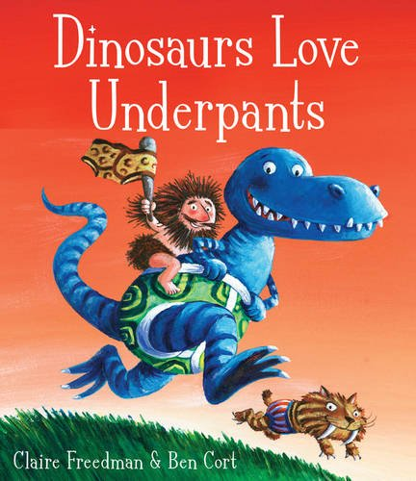](https://www.amazon.co.uk/Dinosaurs-Love-Underpants-Claire-Freedman/dp/184738210X?tag=schoolreadinglist-21)[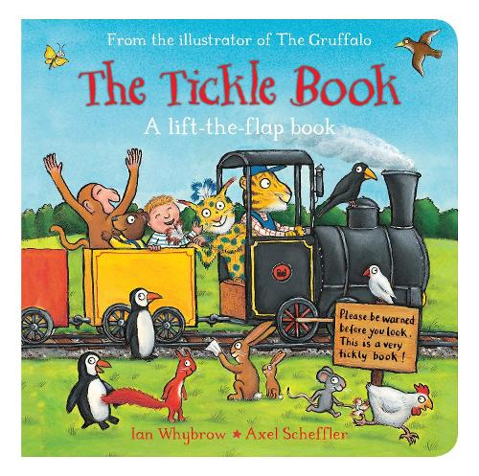](https://www.amazon.co.uk/Tickle-Book-Tom-Bear/dp/1509806970?tag=schoolreadinglist-21)

[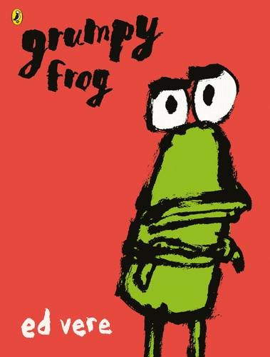](https://www.amazon.co.uk/Grumpy-Frog-Ed-Vere/dp/0141370114?tag=schoolreadinglist-21)

[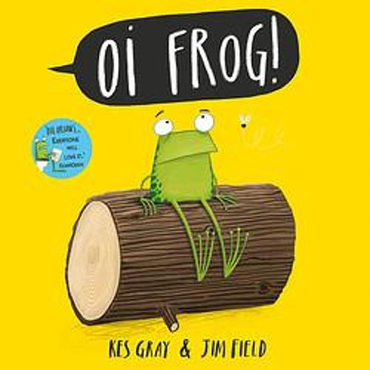](https://www.amazon.co.uk/Oi-Frog-Friends/dp/1444910868?tag=schoolreadinglist-21)[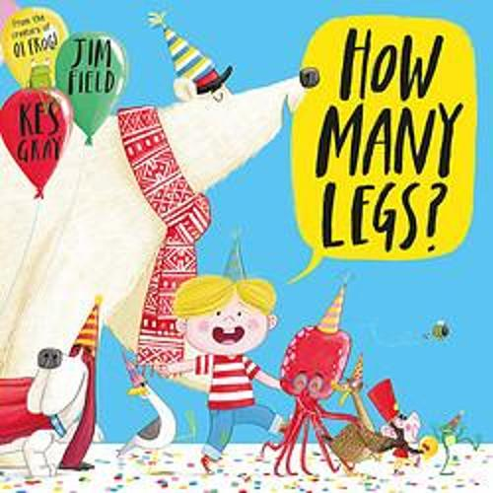](https://www.amazon.co.uk/How-Many-Legs-Kes-Gray/dp/1444910973?tag=schoolreadinglist-21)

[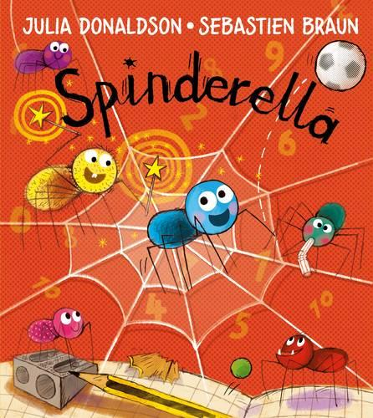](https://www.amazon.co.uk/Spinderella-Julia-Donaldson/dp/140528272X?tag=schoolreadinglist-21)[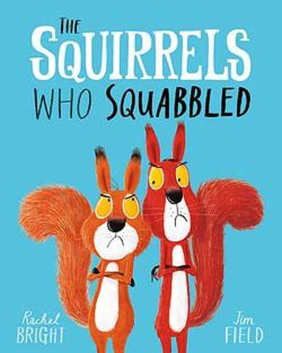](https://www.amazon.co.uk/Squirrels-Who-Squabbled-Rachel-Bright/dp/140834047X?tag=schoolreadinglist-21)

[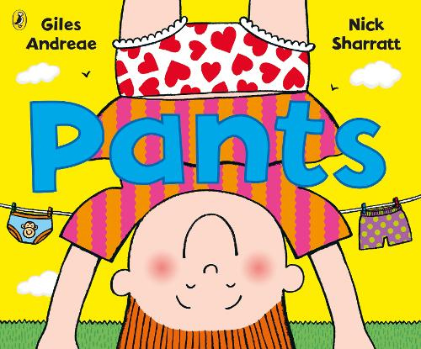](https://www.amazon.co.uk/Pants-Giles-Andreae/dp/0241381681?tag=schoolreadinglist-21)

[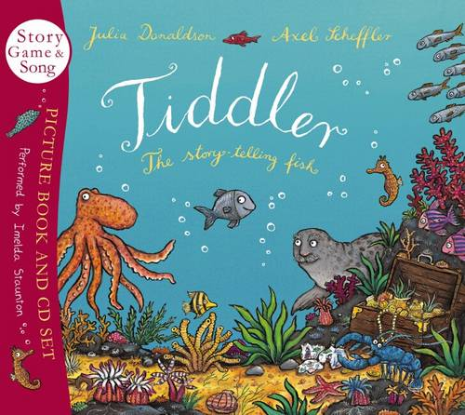](https://www.amazon.co.uk/Tiddler-Julia-Donaldson/dp/1407109898?tag=schoolreadinglist-21)[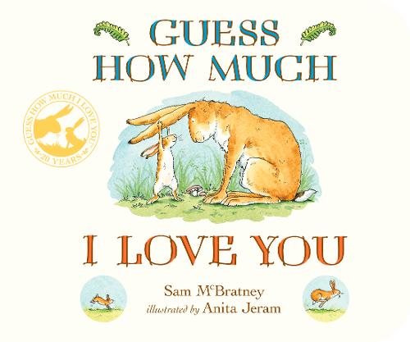](https://www.amazon.co.uk/Guess-How-Much-Love-You/dp/1406358789?tag=schoolreadinglist-21)

[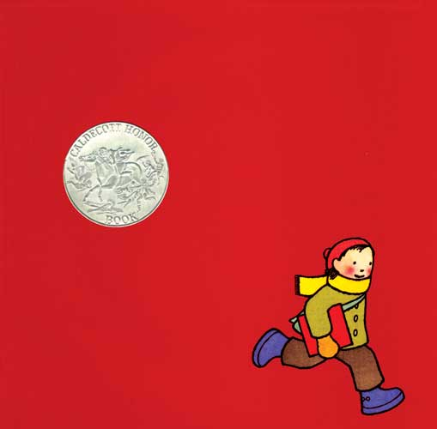](https://www.amazon.co.uk/Red-Book-Caldecott-Honor/dp/0618428585?tag=schoolreadinglist-21)[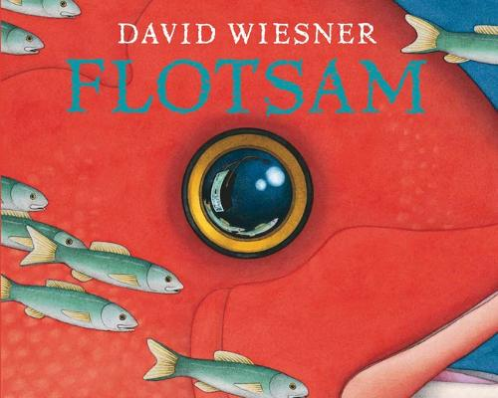](https://www.amazon.co.uk/Flotsam-David-Wiesner/dp/1849394490?tag=schoolreadinglist-21)

[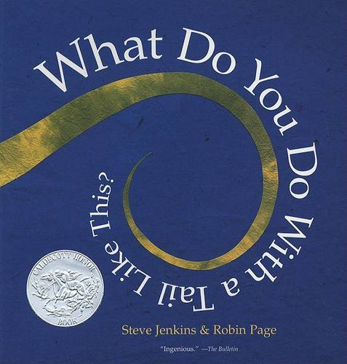](https://www.amazon.co.uk/What-You-Tail-Like-This/dp/061899713X?tag=schoolreadinglist-21)

[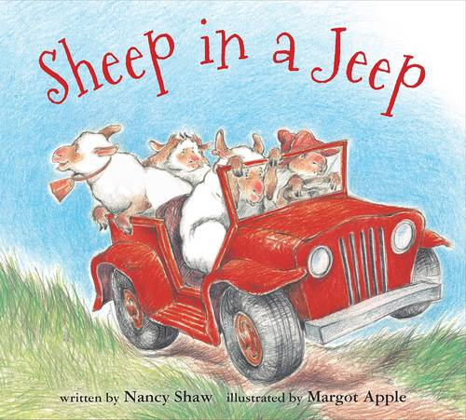](https://www.amazon.co.uk/Sheep-Jeep-Nancy-Shaw/dp/0547338058?tag=schoolreadinglist-21)[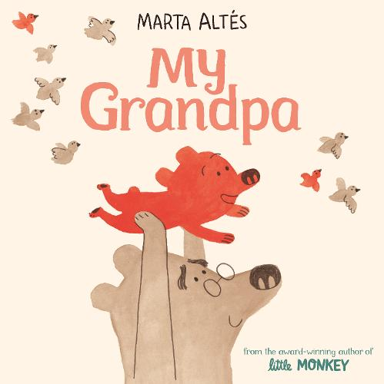](https://www.amazon.co.uk/My-Grandpa-Marta-Alt%C3%A9s/dp/152904510X?tag=schoolreadinglist-21)

[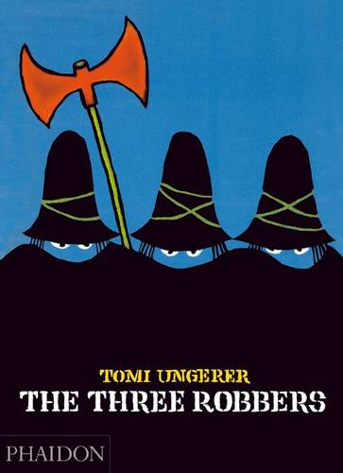](https://www.amazon.co.uk/Three-Robbers-Tomi-Ungerer/dp/0714848778?tag=schoolreadinglist-21)[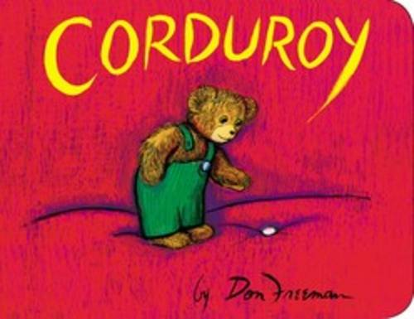](https://www.amazon.co.uk/Corduroy-Board-Book-Don-Freeman/dp/0451470796?tag=schoolreadinglist-21)[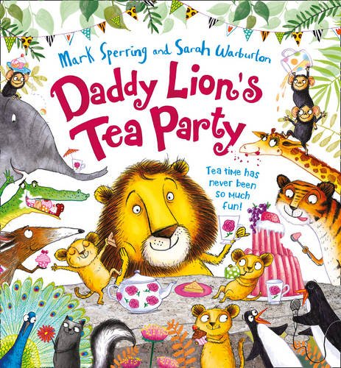](https://www.amazon.co.uk/Daddy-Lions-Party-Mark-Sperring/dp/0007481845?tag=schoolreadinglist-21)

[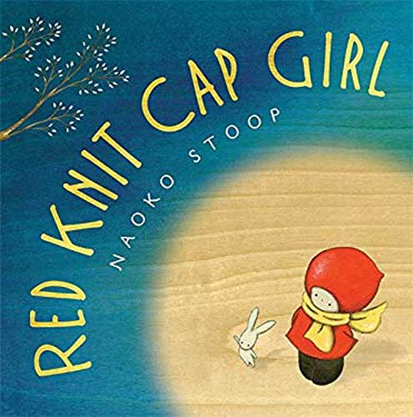](https://www.amazon.co.uk/Red-Knit-Girl-Naoko-Stoop/dp/0316129461?tag=schoolreadinglist-21)[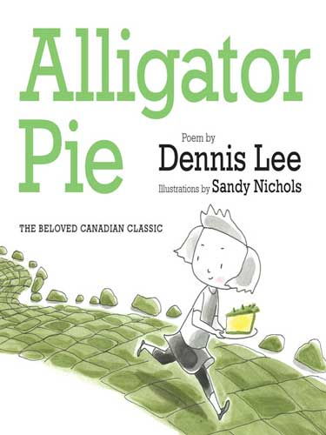](https://www.amazon.co.uk/Alligator-Pie-Dennis-Lee/dp/1443411612?tag=schoolreadinglist-21)

[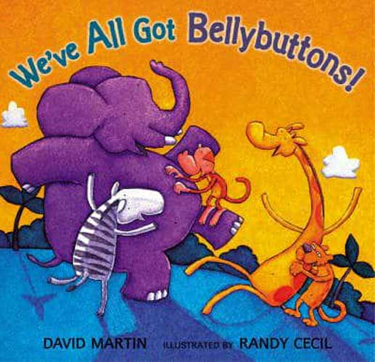](https://www.amazon.co.uk/Weve-All-Bellybuttons-David-Martin/dp/0744593204?tag=schoolreadinglist-21)[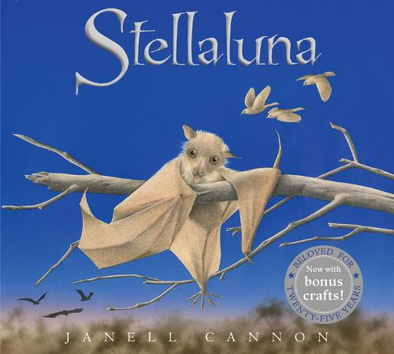](https://www.amazon.co.uk/Stellaluna-Janell-Cannon/dp/0152062874?tag=schoolreadinglist-21)

[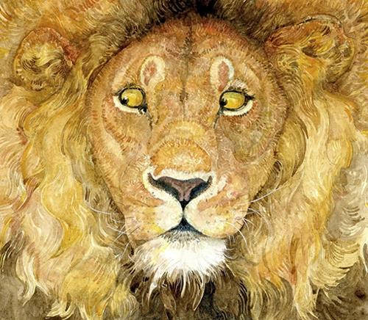](https://www.amazon.co.uk/Lion-Mouse-Jerry-Pinkney/dp/1406332046?tag=schoolreadinglist-21)

[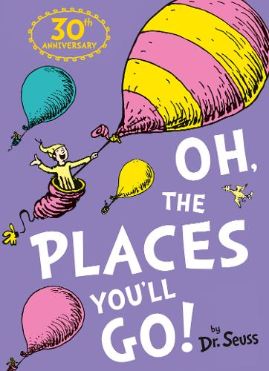](https://www.amazon.co.uk/Oh-Places-Youll-Dr-Seuss/dp/0007413572?tag=schoolreadinglist-21)[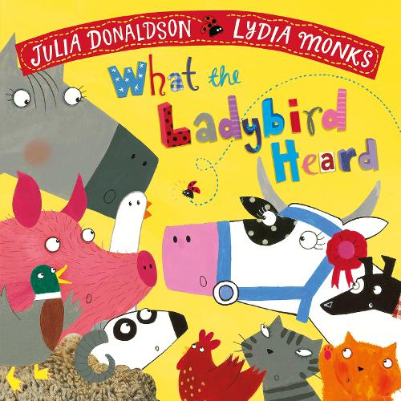](https://www.amazon.co.uk/What-Ladybird-Heard-Julia-Donaldson/dp/1509862560?tag=schoolreadinglist-21)

[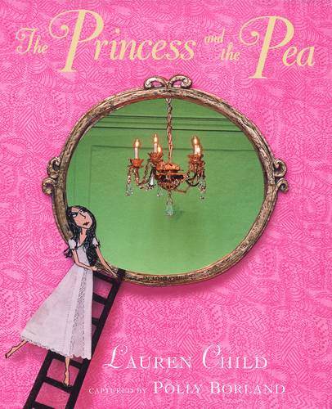](https://www.amazon.co.uk/Princess-Pea-Lauren-Child/dp/014150014X?tag=schoolreadinglist-21)[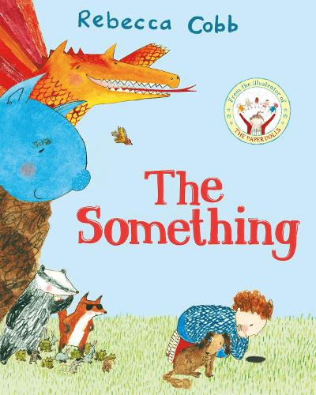](https://www.amazon.co.uk/Something-Rebecca-Cobb/dp/1529017513?tag=schoolreadinglist-21)

[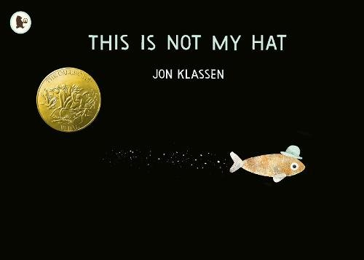](https://www.amazon.co.uk/This-Not-Hat-Jon-Klassen/dp/1406353434?tag=schoolreadinglist-21)

[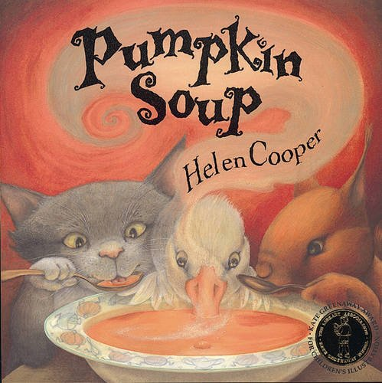](https://www.amazon.co.uk/Pumpkin-Soup-Helen-Cooper/dp/0552545104?tag=schoolreadinglist-21)[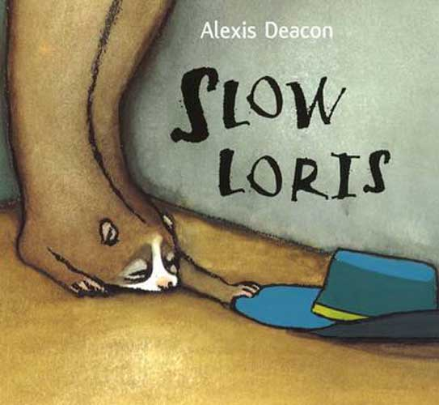](https://www.amazon.co.uk/Slow-Loris-Alexis-Deacon/dp/0099414260?tag=schoolreadinglist-21)

[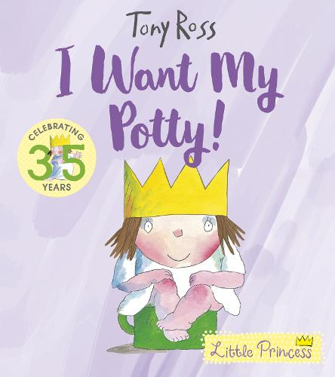](https://www.amazon.co.uk/Want-My-Potty-Little-Princess/dp/1783446323?tag=schoolreadinglist-21)[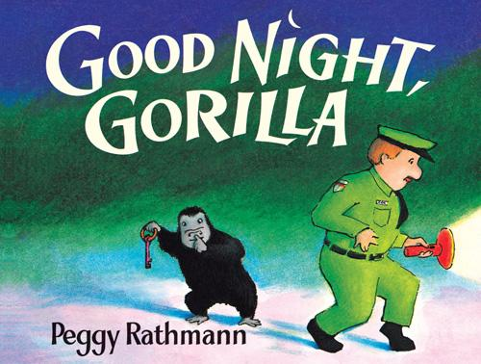](https://www.amazon.co.uk/Good-Night-Gorilla-Peggy-Rathmann/dp/1405263768?tag=schoolreadinglist-21)

[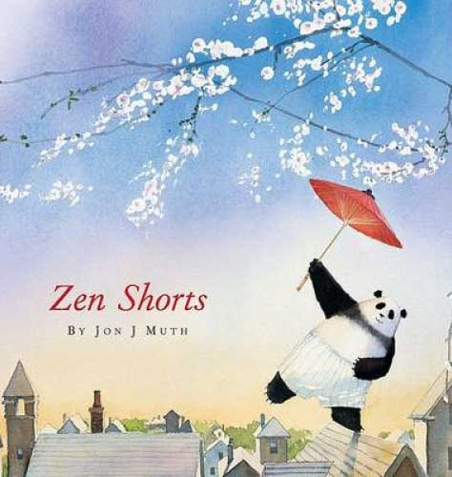](https://www.amazon.co.uk/Zen-Shorts-Author/dp/0439789230?tag=schoolreadinglist-21)

[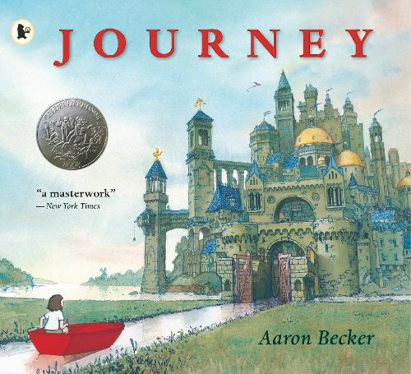](https://www.amazon.co.uk/Journey-Trilogy-1-Aaron-Becker/dp/1406355348?tag=schoolreadinglist-21)[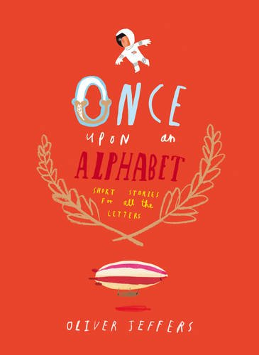](https://www.amazon.co.uk/Once-Upon-Alphabet-Oliver-Jeffers/dp/0007514271?tag=schoolreadinglist-21)

[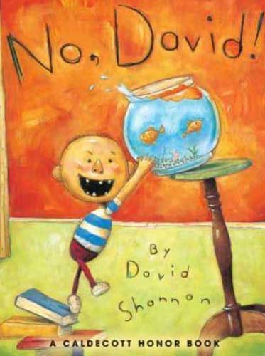](https://www.amazon.co.uk/No-David-Books-Shannon/dp/1338299581?tag=schoolreadinglist-21)[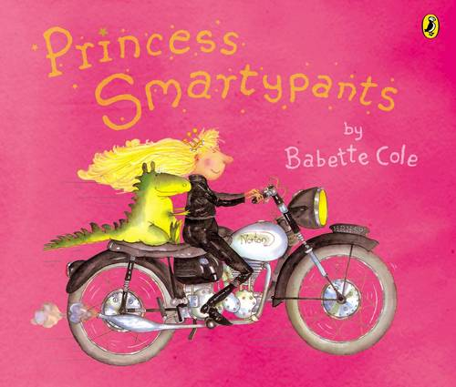](https://www.amazon.co.uk/Princess-Smartypants-Babette-Cole/dp/0140555269?tag=schoolreadinglist-21)

[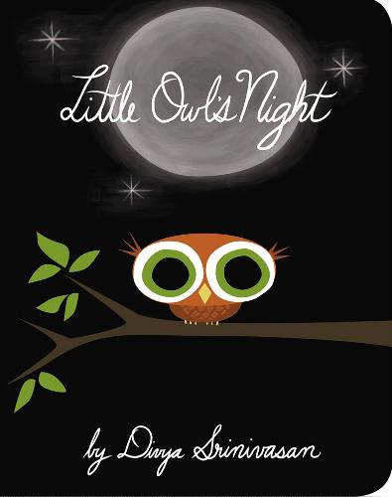](https://www.amazon.co.uk/Little-Owls-Night-Divya-Srinivasan/dp/0670015792?tag=schoolreadinglist-21)

[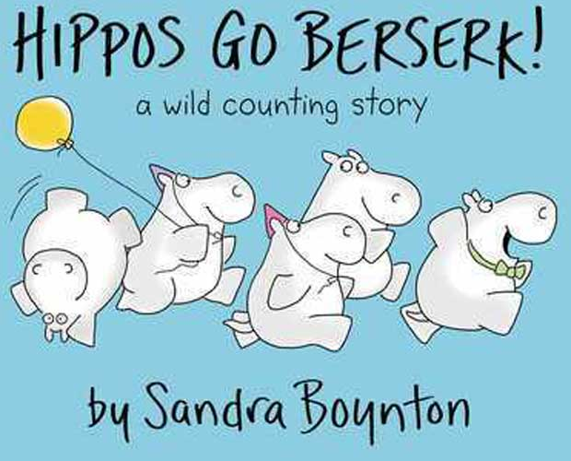](https://www.amazon.co.uk/Hippos-Berserk-Boynton-Sandra-Board/dp/B00M0D3OBM?tag=schoolreadinglist-21)[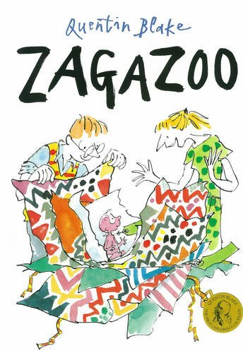](https://www.amazon.co.uk/Zagazoo-Quentin-Blake/dp/0099265346?tag=schoolreadinglist-21)

[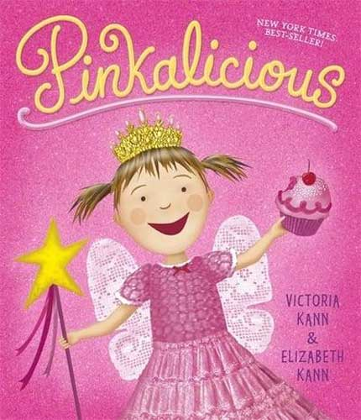](https://www.amazon.co.uk/Pinkalicious-1-Victoria-Kann/dp/1444921614?tag=schoolreadinglist-21)[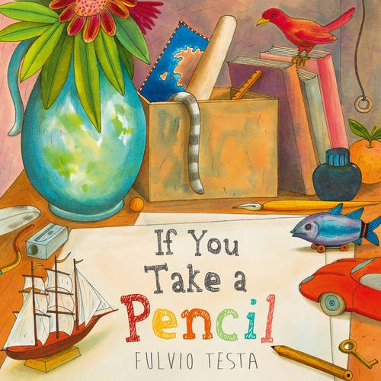](https://www.amazon.co.uk/You-Take-Pencil-Fulvio-Testa/dp/1783445327?tag=schoolreadinglist-21)[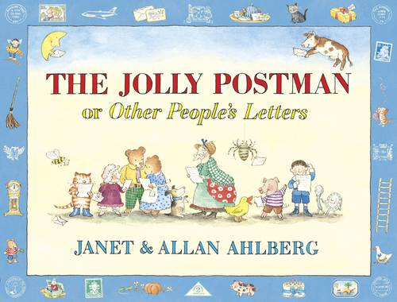](https://www.amazon.co.uk/Jolly-Postman-Allan-Ahlberg/dp/0670886246?tag=schoolreadinglist-21)

[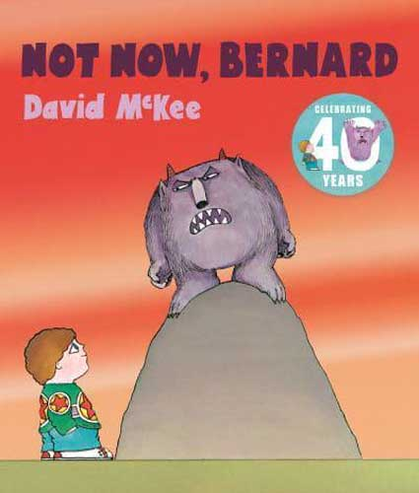](https://www.amazon.co.uk/Not-Now-Bernard-David-McKee/dp/1783442905?tag=schoolreadinglist-21)[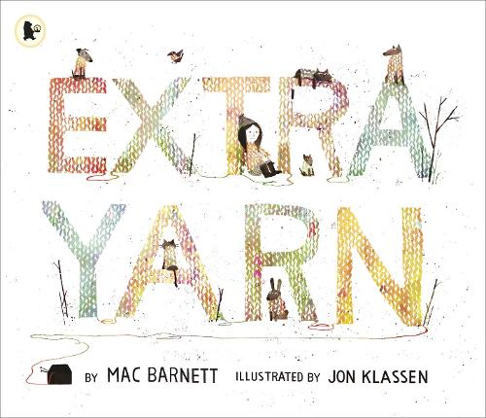](https://www.amazon.co.uk/Extra-Yarn-Mac-Barnett/dp/1406352489?tag=schoolreadinglist-21)

[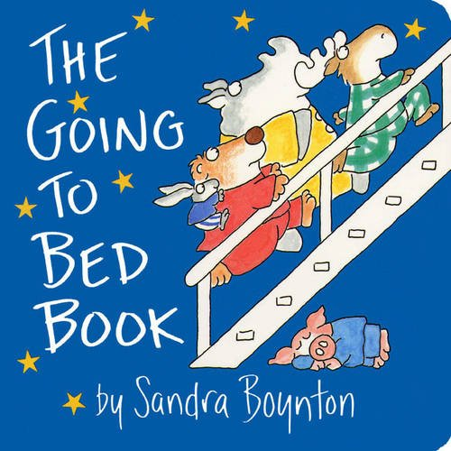](https://www.amazon.co.uk/Going-Bed-Book-BOYNTON/dp/0689861141?tag=schoolreadinglist-21)[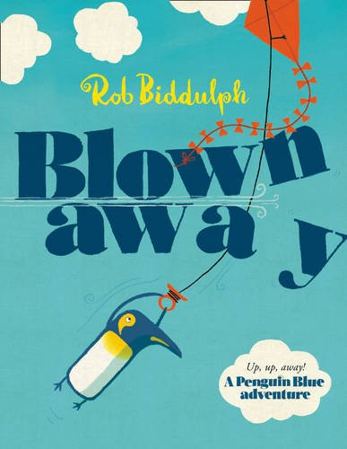](https://www.amazon.co.uk/Blown-Away-Penguin-Blue-Biddulph/dp/0007593821?tag=schoolreadinglist-21)

[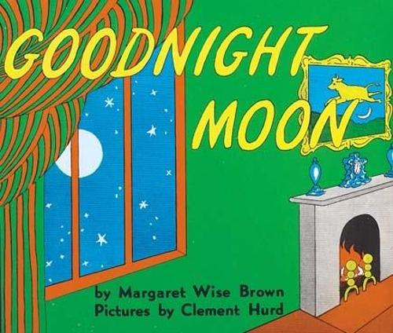](https://www.amazon.co.uk/Goodnight-Moon-Margaret-Wise-Brown/dp/1509829466?tag=schoolreadinglist-21)

[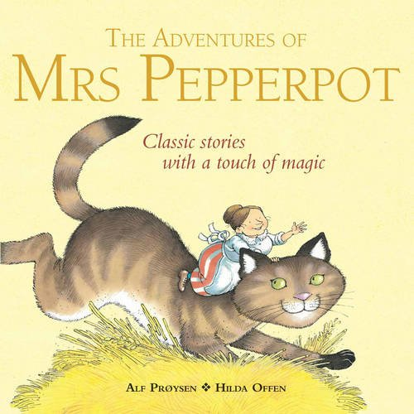](https://www.amazon.co.uk/Adventures-Mrs-Pepperpot-Picture-Books/dp/1849412235?tag=schoolreadinglist-21)[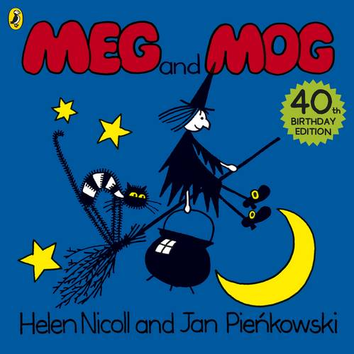](https://www.amazon.co.uk/Meg-Mog-Helen-Nicoll/dp/071819442X?tag=schoolreadinglist-21)

[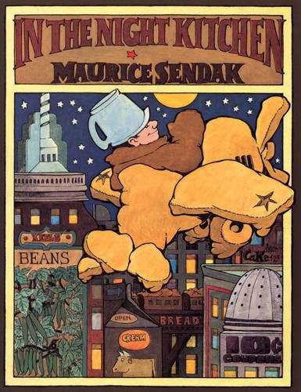](https://www.amazon.co.uk/Night-Kitchen-Maurice-Sendak/dp/0099417472?tag=schoolreadinglist-21)[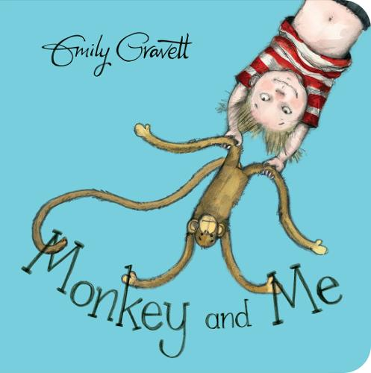](https://www.amazon.co.uk/Monkey-Me-Emily-Gravett/dp/1509841202?tag=schoolreadinglist-21)

[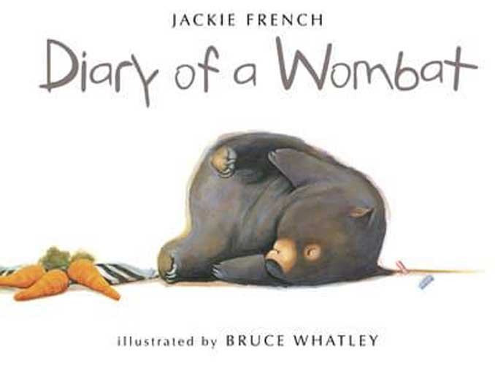](https://www.amazon.co.uk/Diary-Wombat-Jackie-French/dp/0007212070?tag=schoolreadinglist-21)

[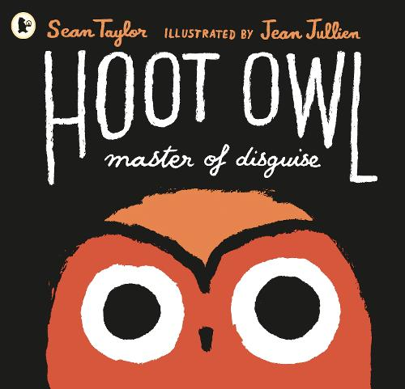](https://www.amazon.co.uk/Hoot-Master-Disguise-Sean-Taylor/dp/1406361011?tag=schoolreadinglist-21)[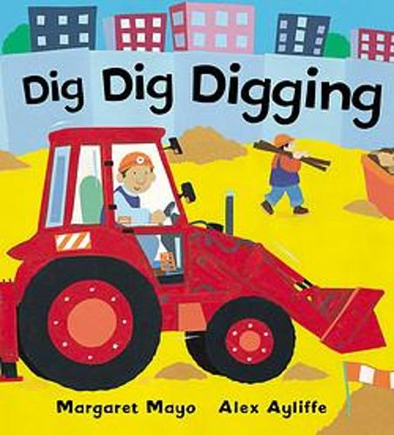](https://www.amazon.co.uk/Dig-Digging-Awesome-Engines/dp/1841210803?tag=schoolreadinglist-21)[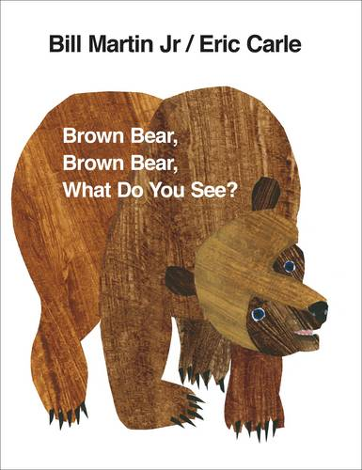](https://www.amazon.co.uk/Brown-Bear-What-You-See/dp/0241137292?tag=schoolreadinglist-21)

[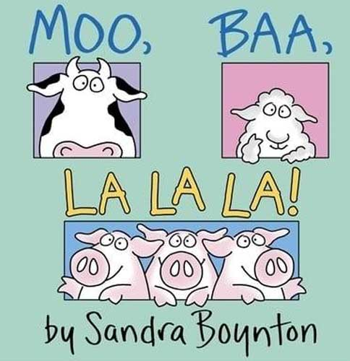](https://www.amazon.co.uk/Moo-Baa-Special-30th-Anniversary/dp/1442454105?tag=schoolreadinglist-21)

[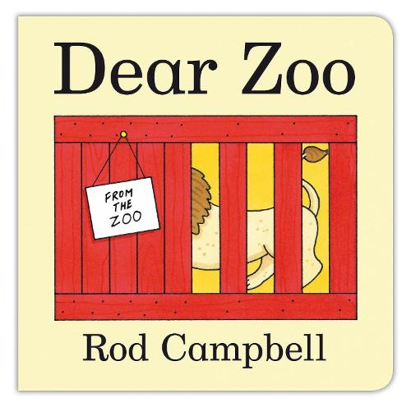](https://www.amazon.co.uk/Dear-Zoo-Rod-Campbell/dp/0230747728?tag=schoolreadinglist-21)

[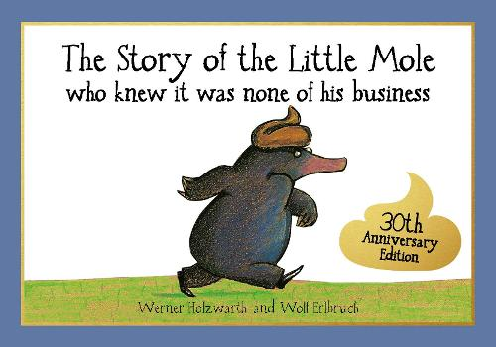](https://www.amazon.co.uk/Story-Little-Business-Children-Picture/dp/1856021017?tag=schoolreadinglist-21)[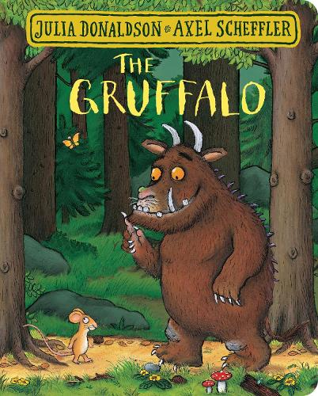](https://www.amazon.co.uk/Gruffalo-Julia-Donaldson/dp/1509830391?tag=schoolreadinglist-21)

[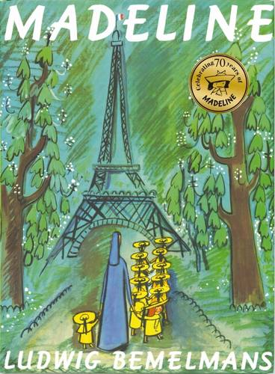](https://www.amazon.co.uk/Madeline-Ludwig-Bemelmans/dp/1407110535?tag=schoolreadinglist-21)[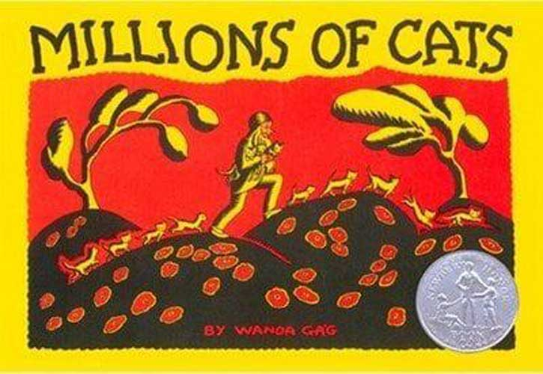](https://www.amazon.co.uk/Millions-Cats-Picture-Puffin-Books/dp/0142407089?tag=schoolreadinglist-21)

[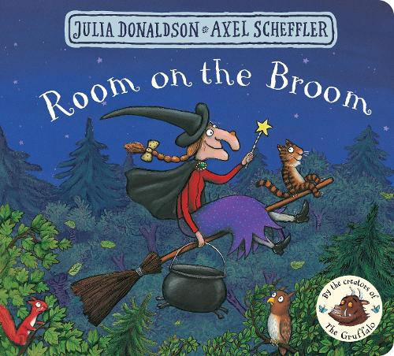](https://www.amazon.co.uk/Room-Broom-Julia-Donaldson/dp/150983043X?tag=schoolreadinglist-21)

[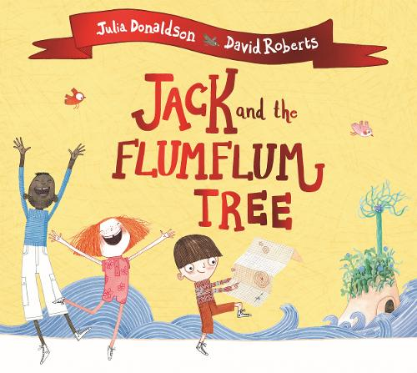](https://www.amazon.co.uk/Jack-Flumflum-Tree-Julia-Donaldson/dp/1509892451?tag=schoolreadinglist-21)

[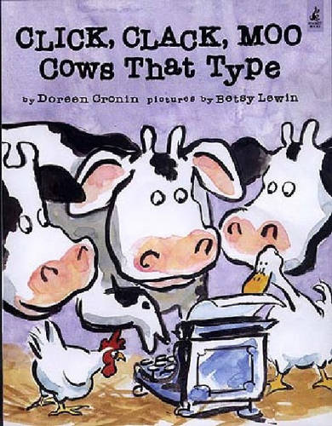](https://www.amazon.co.uk/Doreen-Cronin-Click-Clack-Moo/dp/0743461517?tag=schoolreadinglist-21)

[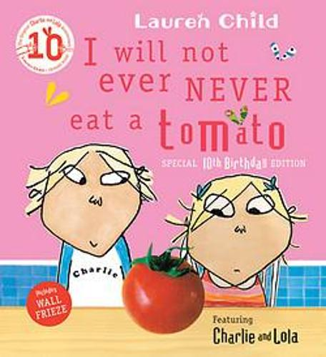](https://www.amazon.co.uk/Will-Ever-Never-Tomato-Charlie/dp/1846168864?tag=schoolreadinglist-21)[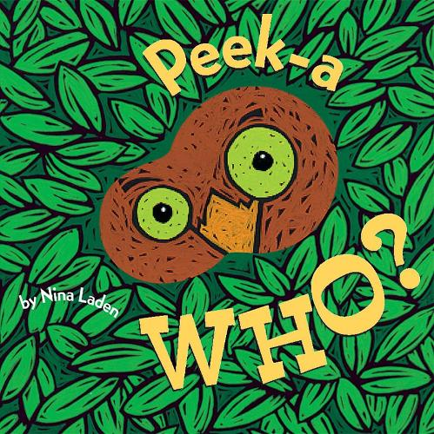](https://www.amazon.co.uk/Peek-Who-Nina-Laden/dp/0811826023?tag=schoolreadinglist-21)

[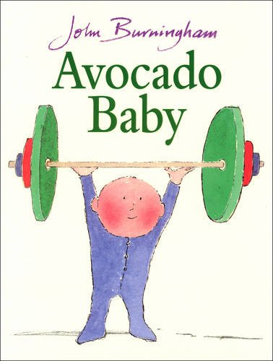](https://www.amazon.co.uk/Avocado-Baby-Red-Picture-Books/dp/0099200619?tag=schoolreadinglist-21)

[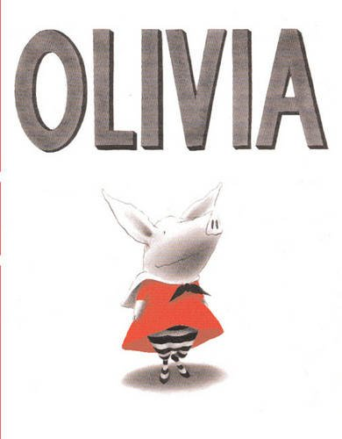](https://www.amazon.co.uk/Olivia-Ian-Falconer/dp/0689860889?tag=schoolreadinglist-21)

[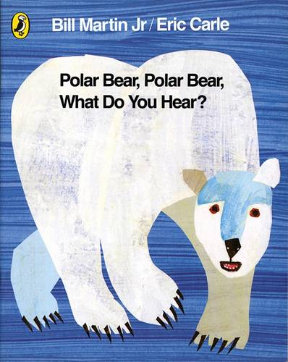](https://www.amazon.co.uk/Polar-Bear-What-You-Hear/dp/0141383518?tag=schoolreadinglist-21)

[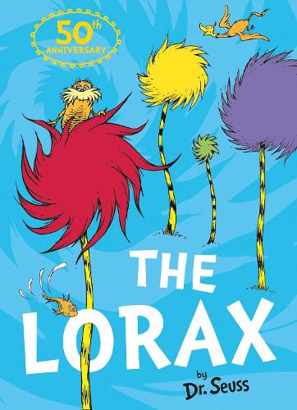](https://www.amazon.co.uk/Lorax-Dr-Seuss/dp/0007455933?tag=schoolreadinglist-21)[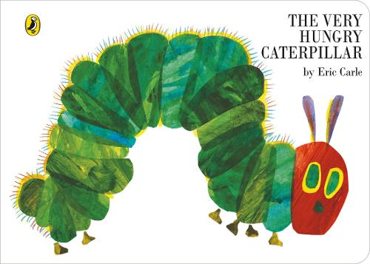](https://www.amazon.co.uk/Very-Hungry-Caterpillar-Board-Book/dp/0241003008?tag=schoolreadinglist-21)[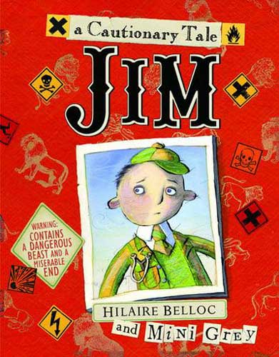](https://www.amazon.co.uk/Jim-Away-Nurse-Eaten-Lion/dp/0375859705?tag=schoolreadinglist-21)

[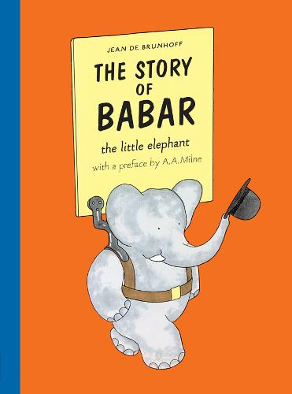](https://www.amazon.co.uk/Story-Babar-Jean-Brunhoff/dp/1405238186?tag=schoolreadinglist-21)[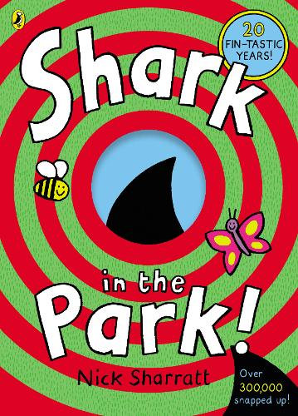](https://www.amazon.co.uk/Shark-Park-Nick-Sharratt/dp/0552549770?tag=schoolreadinglist-21)

[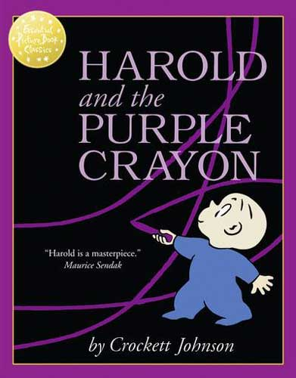](https://www.amazon.co.uk/Harold-Purple-Essential-Picture-Classics/dp/0007464371?tag=schoolreadinglist-21)[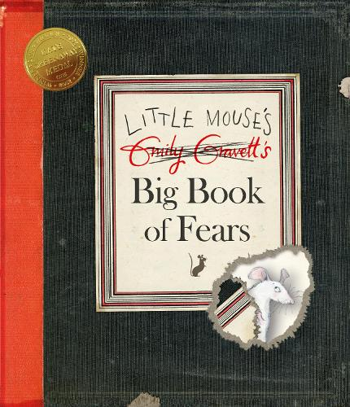](https://www.amazon.co.uk/Little-Mouses-Big-Book-Fears/dp/0230016197?tag=schoolreadinglist-21)

[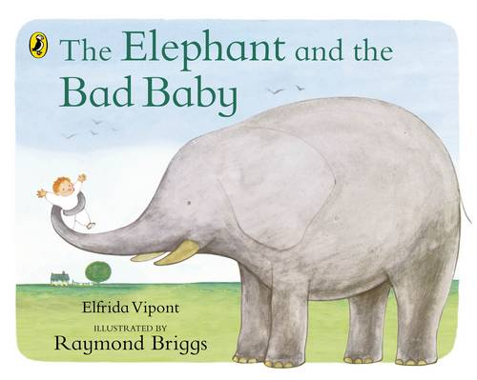](https://www.amazon.co.uk/Elephant-Baby-Puffin-Picture-Books/dp/0140500480?tag=schoolreadinglist-21)

[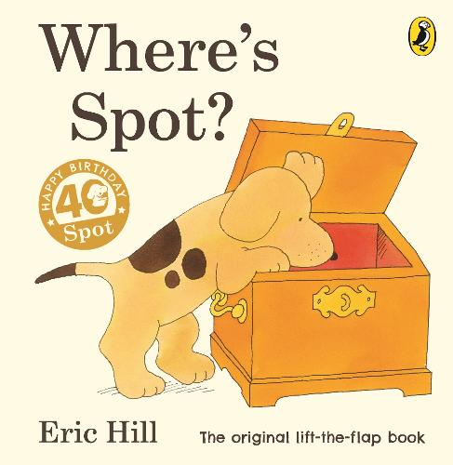](https://www.amazon.co.uk/Wheres-Spot-Original-Lift-Flap/dp/0723263663?tag=schoolreadinglist-21)[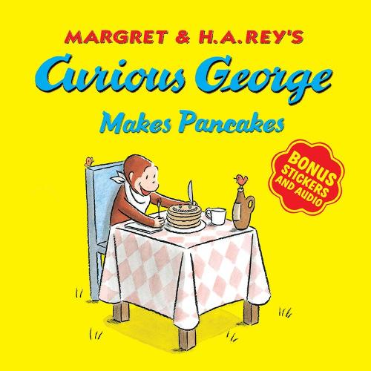](https://www.amazon.co.uk/Curious-George-Makes-Pancakes-Stickers/dp/1328581314?tag=schoolreadinglist-21)

[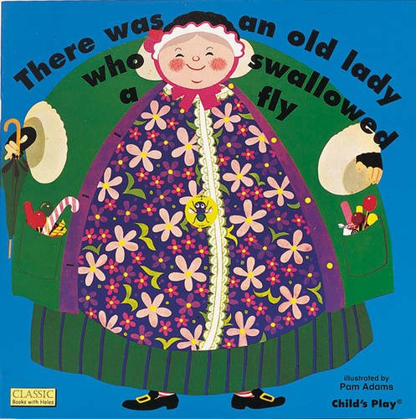](https://www.amazon.co.uk/There-Swallowed-Classic-Books-Holes/dp/0859537277?tag=schoolreadinglist-21)[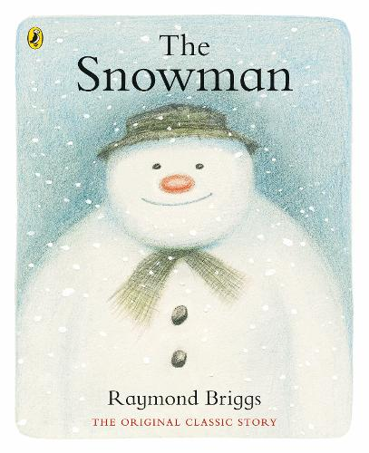](https://www.amazon.co.uk/Snowman-Raymond-Briggs/dp/072327553X?tag=schoolreadinglist-21)[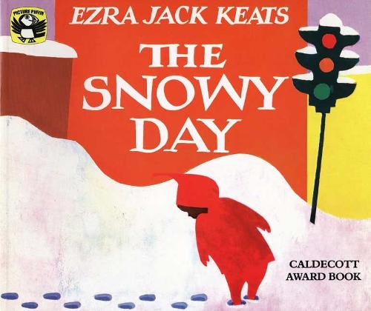](https://www.amazon.co.uk/Snowy-Day-Picture-Puffin-S/dp/0140501827?tag=schoolreadinglist-21)

[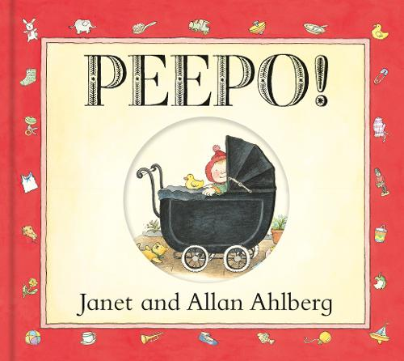](https://www.amazon.co.uk/Peepo-Board-Book-Allan-Ahlberg/dp/0141337427?tag=schoolreadinglist-21)[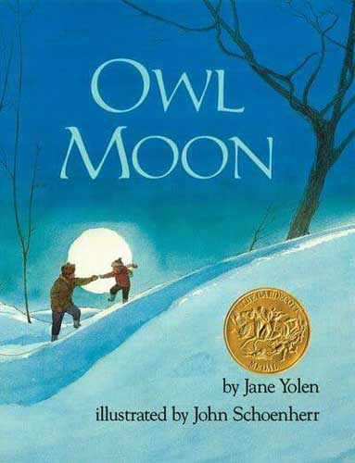](https://www.amazon.co.uk/Owl-Moon-Jane-Yolen/dp/0399214577?tag=schoolreadinglist-21)

[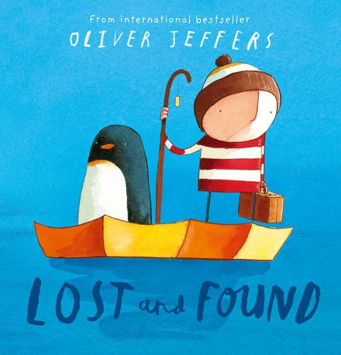](https://www.amazon.co.uk/Lost-Found-Oliver-Jeffers/dp/0007150369?tag=schoolreadinglist-21)[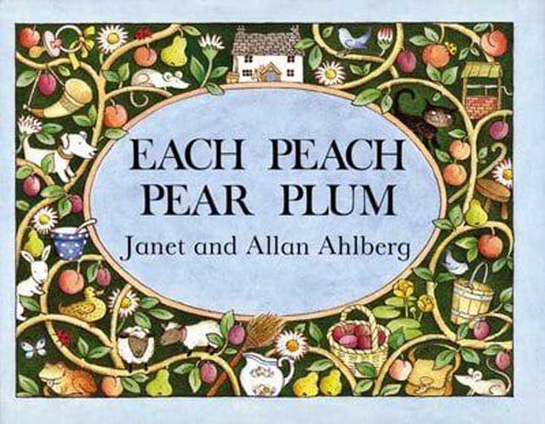](https://www.amazon.co.uk/Peach-Viking-Kestrel-Picture-Books/dp/067088278X?tag=schoolreadinglist-21)

[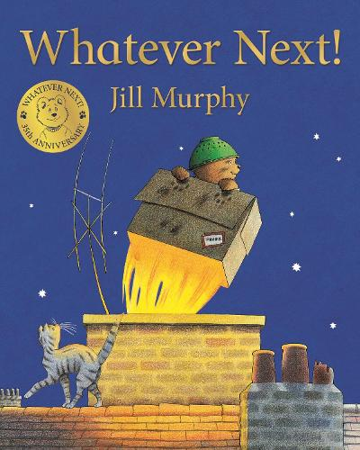](https://www.amazon.co.uk/Whatever-Next-Jill-Murphy/dp/1509862587?tag=schoolreadinglist-21)