ST. FRANCIS XAVIER SCHOOLS
ACADEMIC CALENDAR 2022/23

TERM 1

Re-opening Tuesday, 30th August 2022

Midterm 31st October - 4th November (inclusive)

Christmas Break
- Closing Wednesday 21st December at 12 noon
- Reopening Thursday, 5th January 2023

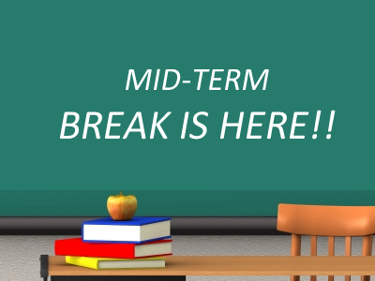 | TERM 2  St. Brigid’s Day Closures: Fri 3rd Feb - Mon 6th Feb (inclusive)  Midterm Break Thurs 16th & Friday, 17th February
 | St. Patrick’s Day Closures: Thurs 16th & Friday 17th March
Easter Break
- School closes Friday 31st March at 12 noon
- Reopening Monday, 17th April

TERM 3

May Bank Holiday Monday, 1st May

June Week Mon 5th - Fri 9th June (inclusive)
Summer Holidays Friday, 30th June at 12noon

